|  |  |  |  |  |  |
| --- | --- | --- | --- | --- | --- |
| **Test Case Id:117** | | **Test Purpose: Test table of students in a tutor group is displayed** | | | |
| **Environment:Windows 10** | | | | | |
| **Preconditions:None** | | | | | |
| **Test Case Steps:** | | | | | |
| Step No | Procedure | | | Response | Pass/Fail |
| 1 | Run gui.py in command prompt | | | Personal tutor system opens up (fig.1) | Pass |
| 2 | Click list of tutees for a particular personal tutor | | | Another branch of the personal tutor system opens up (fig.2) | pass |
| 3 | Type testory into the input field (fig 3) | | |  | pass |
| 4 | Press the enter button | | | A table of students with tutor testory is displayed (fig.4) | pass |
| 5 | Change the input field to testor (fig.5) | | |  | pass |
| 6 | Press the enter button | | | A table of students with tutor testor is displayed (fig.6) | pass |
|  |  | | |  |  |
|  |  | | |  |  |
|  |  | | |  |  |
|  |  | | |  |  |
| **Comments:** | | | | | |
| **Related Tests:** | | | | | |
| **Author: Alastair Morgan (23/03/17)** | | | **Checker: Lili Rossiter** | | |

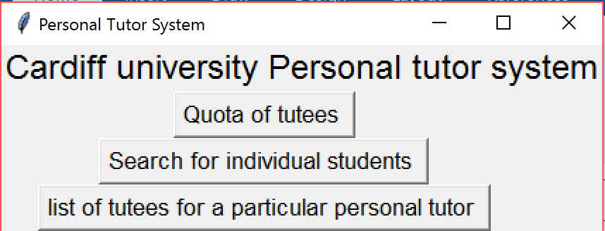

**Fig 1**

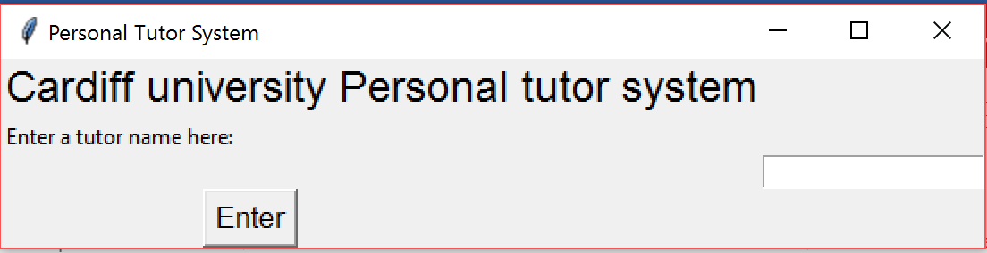

**Fig 2**

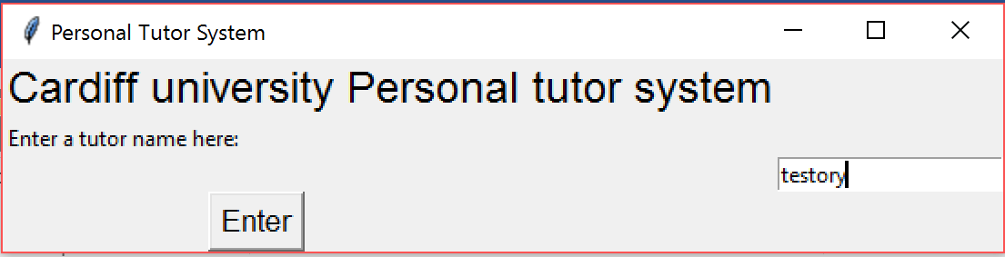

**Fig 3**

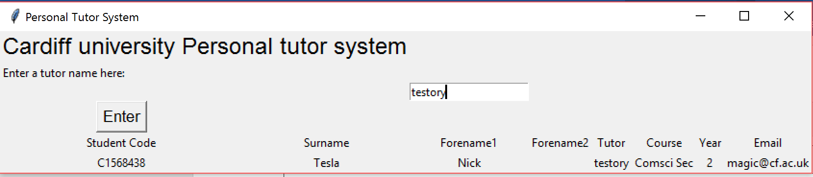

**Fig 4**

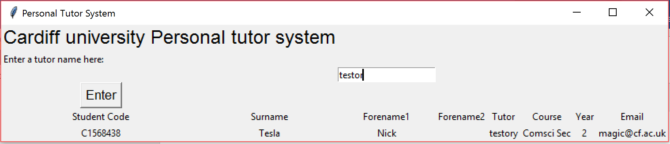

**Fig 5**

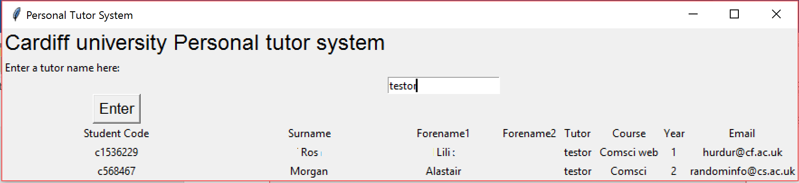

**Fig 6**